Programming Laboratory-I
Assignment No-2
(Constructors, Destructors and Static members)

Name: Naman Sunil Bharsakale
Prn No: 255200003
Branch: Computer Science and Engineering(Aided)
Batch: S8

- Create a class Film
- With private members as Name, Language, Type and Duration.
- Create a default constructor to initialize Language and Duration as ‘Hindi’ and 3 (hrs.)
- Create parameterized constructor to insert another movie details.
- Display all the details. (Use destructor as well)
Input:
class Film {
private String name;
private String language;
private String type;
private int duration;

public Film() {
this.language = "Hindi";
this.duration = 3;
this.name = "Unknown";
this.type = "Drama";
}

public Film(String name, String language, String type, int duration) {
this.name = name;
this.language = language;
this.type = type;
this.duration = duration;
}

public void display() {
System.out.println("----- Film Details -----");
System.out.println("Name: " + name);
System.out.println("Language: " + language);
System.out.println("Type: " + type);
System.out.println("Duration: " + duration + " hrs");
System.out.println("------------------------");
}

public void destroy() {
System.out.println("Destructor (simulated) called for film: " + name);
}
}

public class Assignment1 {
public static void main(String[] args) {
Film film1 = new Film();
film1.display();

Film film2 = new Film("Inception", "English", "Sci-Fi", 2);
film2.display();

film1.destroy();
film2.destroy();
}
}
Output:
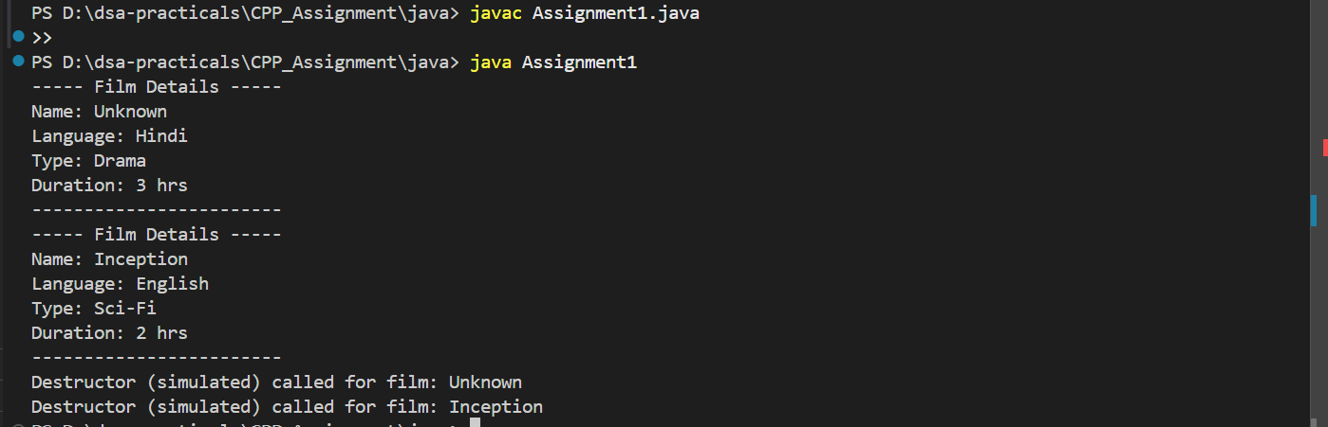

- Create a class Customer
- With private members as Cid, Cname, Age, City.
- Use default constructor to assign default values.
- Use parameterized constructor to assign values to it.
- Display all Customer information. (Add at least 5 records)
Input:
class Customer {
private int cid;
private String cname;
private int age;
private String city;

public Customer() {
this.cid = 0;
this.cname = "Unknown";
this.age = 0;
this.city = "Not specified";
}

public Customer(int cid, String cname, int age, String city) {
this.cid = cid;
this.cname = cname;
this.age = age;
this.city = city;
}

public void display() {
System.out.println("----- Customer Details -----");
System.out.println("Customer ID: " + cid);
System.out.println("Name: " + cname);
System.out.println("Age: " + age);
System.out.println("City: " + city);
System.out.println("----------------------------");
}
}

public class Assignment1b {
public static void main(String[] args) {
Customer c1 = new Customer();
Customer c2 = new Customer(101, "Amit", 25, "Mumbai");
Customer c3 = new Customer(102, "Sneha", 28, "Pune");
Customer c4 = new Customer(103, "Rahul", 30, "Delhi");
Customer c5 = new Customer(104, "Priya", 22, "Nashik");
Customer c6 = new Customer(105, "Karan", 27, "Nagpur");

c1.display();
c2.display();
c3.display();
c4.display();
c5.display();
c6.display();
}
}
Output:
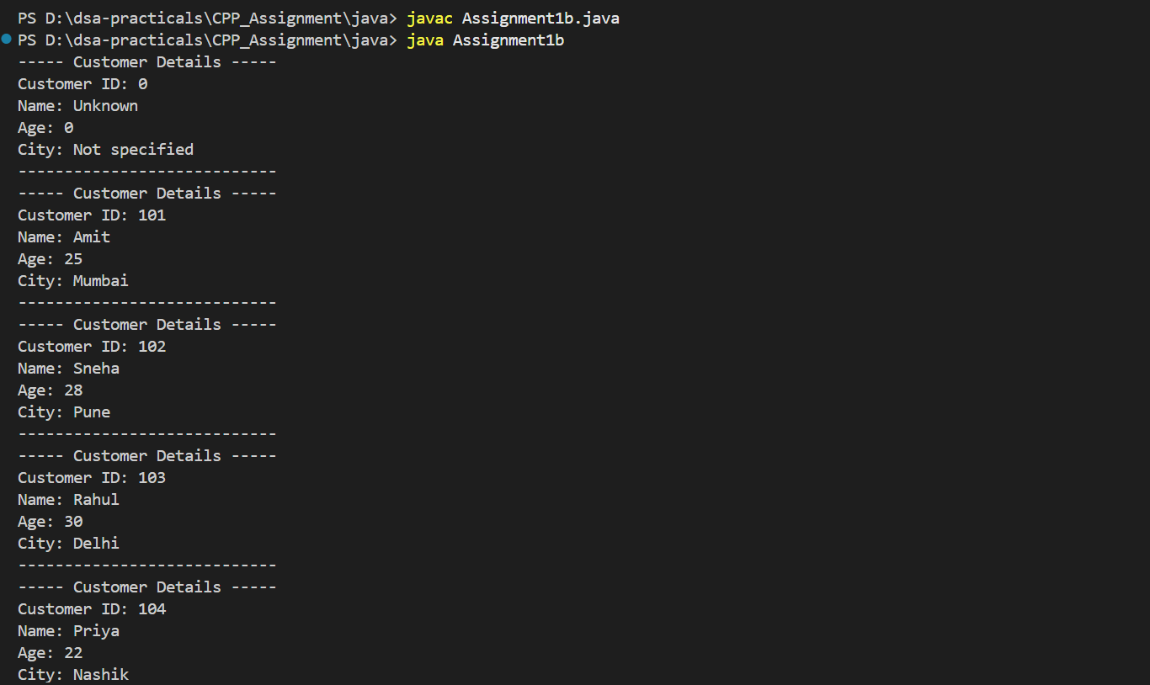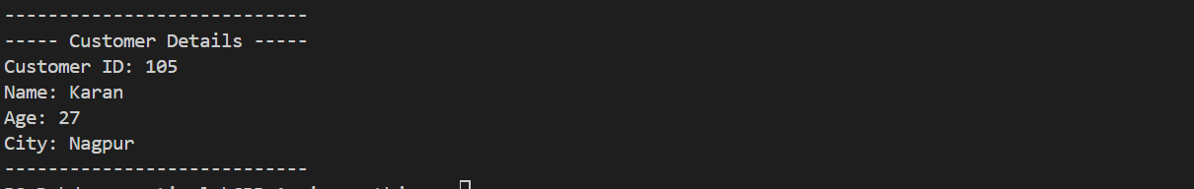

- Create a Vector class:
- A private pointer to an array of doubles, and a size.
- A default constructor that initializes a size 5 array filled with zeros.
- A parameterized constructor that takes size and initializes the array with that size filled with zeros.
- A destructor that releases memory.
- A function display() to show the array elements.
Input:
class Vector {
private double[] arr;
private int size;

public Vector() {
this.size = 5;
this.arr = new double[size];
for (int i = 0; i < size; i++) {
arr[i] = 0.0;
}
}

public Vector(int size) {
this.size = size;
this.arr = new double[size];
for (int i = 0; i < size; i++) {
arr[i] = 0.0;
}
}

public void display() {
System.out.print("Vector elements: ");
for (int i = 0; i < size; i++) {
System.out.print(arr[i] + " ");
}
System.out.println();
}

// Destructor simulation
public void destroy() {
arr = null; // Allow garbage collector to free memory
System.out.println("Vector memory released.");
}
}

public class Assignment1c {
public static void main(String[] args) {
Vector v1 = new Vector();
v1.display();

Vector v2 = new Vector(8);
v2.display();

v1.destroy();
v2.destroy();
}
}
Output:
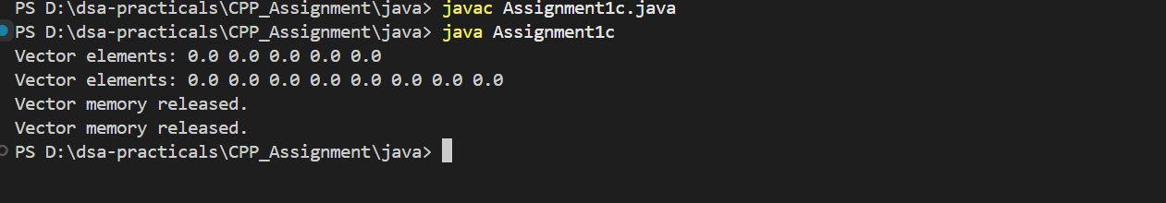

- Create a class Operations with overloaded functions named operate:
- One that returns the sum of two integers.
- One that returns the product of two doubles.
- One that concatenates two strings.
- In the main function, create an object of Operations and use it to perform the three operations and print the results.
Input:
class Operations {

// Sum of two integers
public int operate(int a, int b) {
return a + b;
}

// Product of two doubles
public double operate(double a, double b) {
return a * b;
}

// Concatenation of two strings
public String operate(String a, String b) {
return a + b;
}
}

public class Assignment1d {
public static void main(String[] args) {
Operations op = new Operations();

int sum = op.operate(10, 20);
double product = op.operate(5.5, 2.0);
String concatenated = op.operate("Hello, ", "World!");

System.out.println("Sum of integers: " + sum);
System.out.println("Product of doubles: " + product);
System.out.println("Concatenated string: " + concatenated);
}
}
Output:
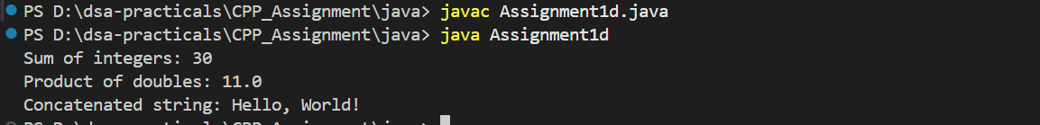
- Create a class PrintData with three overloaded functions named print:
- One that prints an integer.
- One that prints a double.
- One that prints a string.
Input:
class PrintData {

// Print integer
public void print(int a) {
System.out.println("Integer: " + a);
}

// Print double
public void print(double a) {
System.out.println("Double: " + a);
}

// Print string
public void print(String a) {
System.out.println("String: " + a);
}
}

public class Assignment5 {
public static void main(String[] args) {
PrintData pd = new PrintData();

pd.print(42); // integer
pd.print(3.14159); // double
pd.print("Hello, Java!"); // string
}
}
Output:
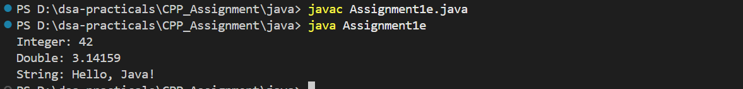

- Create a Team class that manages team members up to a fixed maximum size (e.g., 10). The class should have:

- An array of strings to store names of team members.
- A counter to keep track of the current number of team members.
- A default constructor that initializes an empty team.
- Overloaded member function addMember:
- One that adds a member by name.
- One that adds a generic member named "Unknown" followed by its index (like "Unknown1", "Unknown2", ...).
- A member function displayTeam to show the team members.
Instructions:
- Define the Team class with the features mentioned above.
- In the main function:
- Create an instance of the Team class.
- Add members using both versions of the addMember function.
- Display the team members.
Input:
class Team {
private String[] members;
private int count;
private final int MAX_SIZE = 10;

public Team() {
members = new String[MAX_SIZE];
count = 0;
}

public void addMember(String name) {
if (count < MAX_SIZE) {
members[count] = name;
count++;
} else {
System.out.println("Team is full! Cannot add more members.");
}
}

public void addMember() {
if (count < MAX_SIZE) {
members[count] = "Unknown" + (count + 1);
count++;
} else {
System.out.println("Team is full! Cannot add more members.");
}
}

public void displayTeam() {
System.out.println("Team Members (" + count + "):");
for (int i = 0; i < count; i++) {
System.out.println((i + 1) + ". " + members[i]);
}
System.out.println("------------------------");
}
}

public class Assignment1f {
public static void main(String[] args) {
Team myTeam = new Team();

// Add members by name
myTeam.addMember("Alice");
myTeam.addMember("Bob");
myTeam.addMember("Charlie");

// Add generic members
myTeam.addMember();
myTeam.addMember();

// Display team members
myTeam.displayTeam();
}
}
Output:
